Number of Zero Values Between Treatments
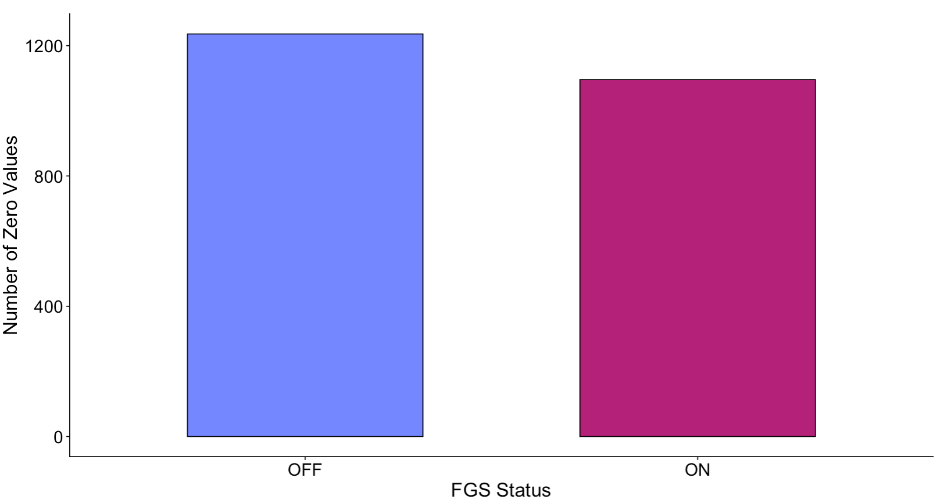
Figure 1. Bar plot showing the number of zero values between treatments. The FGS was installed when the FGS Status was ON and uninstalled when the FGS Status was OFF.

Duration of Seal Presence

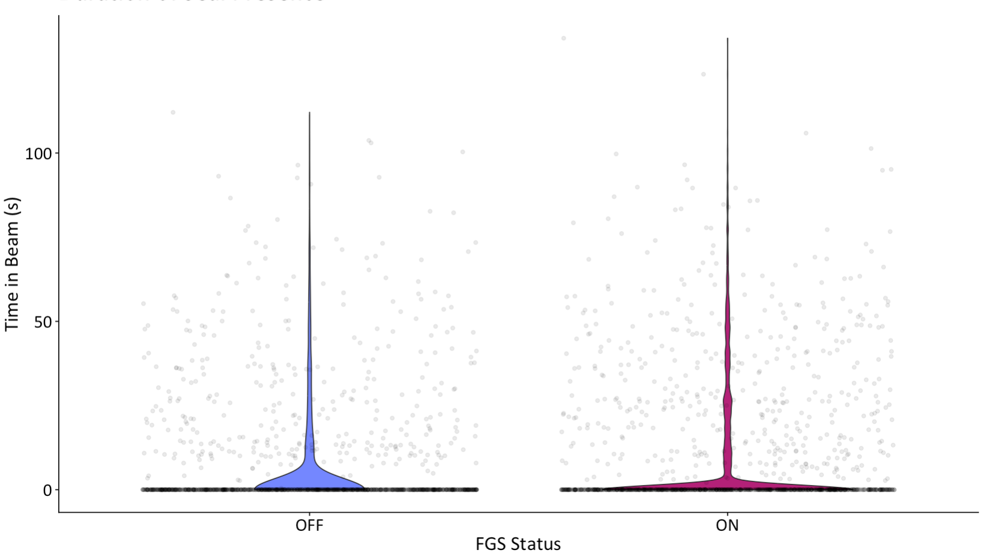
Figure 2. Violin plot showing the duration of seal presence for both FGS treatments.

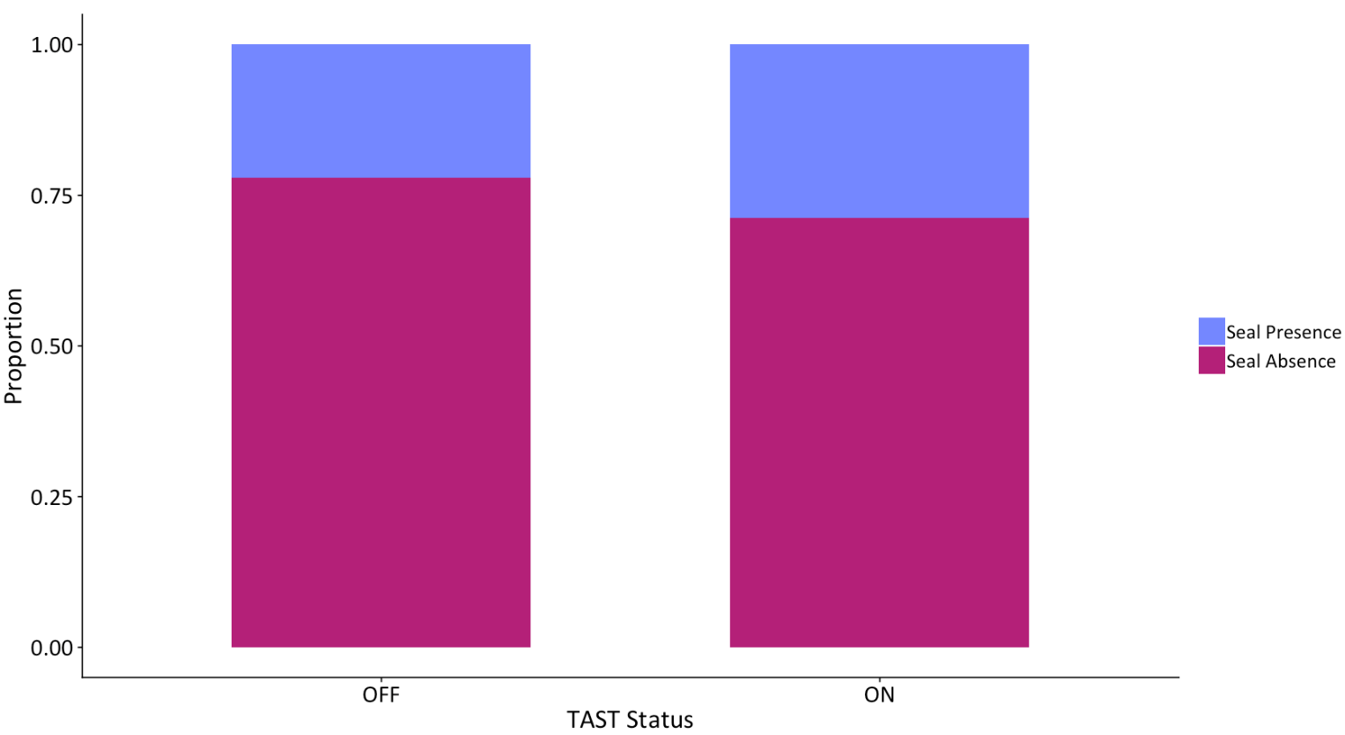
Proportion of Seal Presence vs. Absence
Figure 3. Stacked bar plot showing the proportion of files that contained seals to those that did not contain seals for each FGS treatment.

